Custom Safety and Guarding Solutions Be Proactive, Not Reactive

Customizable Guarding for All Your Machinery
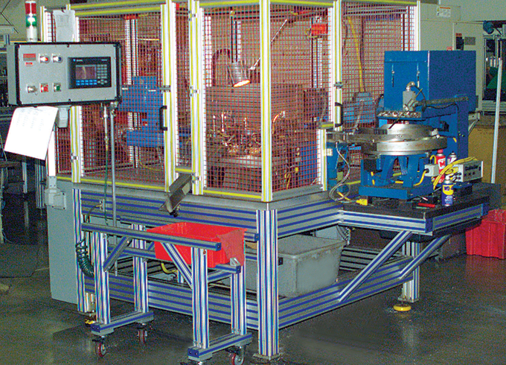
From cycle time, to throughput, to changeover metrics, there's no end to the daily concerns and issues that you deal with in an industrial marketplace. You're tasked with continually improving key metrics as well as complying with evolving regulations, which means change is the only constant.
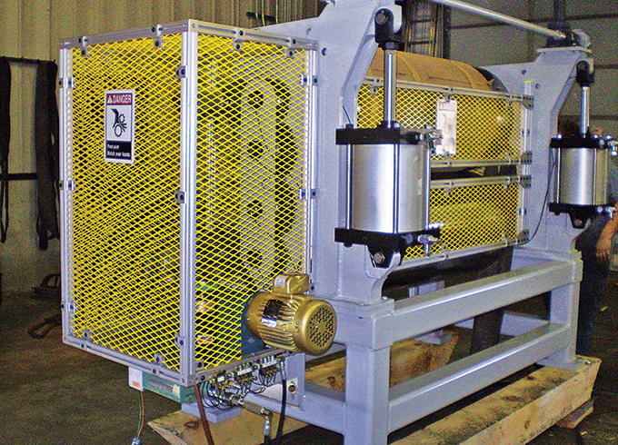

Injury and hefty fines are results of inadequate preventative protection measures. Whether it’s a machine guard, storage enclosure or visual barrier, the application needs to fit your equipment and your processes.

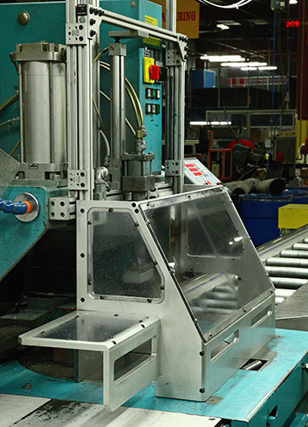
Customizable Products
American Equipment now offers a wide range of customizable products for the specific guarding and enclosure to limit your risks, damage and expenses. The anodized aluminum T-slot profile system allows you to mount additional safety components such as switches, security cameras, light relays, or locks.
It is a modular solution, meaning when your equipment, inventory, personnel or regulations change or evolve, you simply reconfigure your existing design to accommodate.
- Adjustable, liftoff, and locking hinges

- Casters

- Handles for doors and access points

- Leveling feet

- Wide range of aluminum T-slot profiles for your light to heavy-duty needs

- Variety of panels, wire mesh and aluminum plates

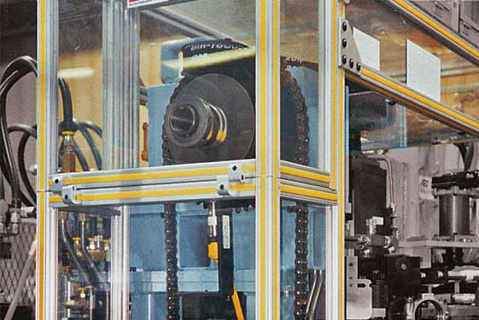

HDPE Clear
Corrosion resistant
Hides scratches
Excellent alternative to stainless steel.

Protection for Your People & Property

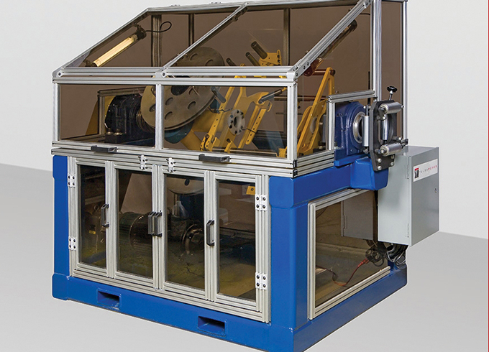
Meet OSHA Requirements

Personal and property safety initiatives are imperative in every business. Injury and hefty fines are results of inadequate preventative protection measures. Whether it’s a machine guard, storage enclosure or visual barrier, the application needs to fit to your equipment and your processes. It must accommodate maintenance and repairs, incorporate other safety components, and meet all OSHA requirements.

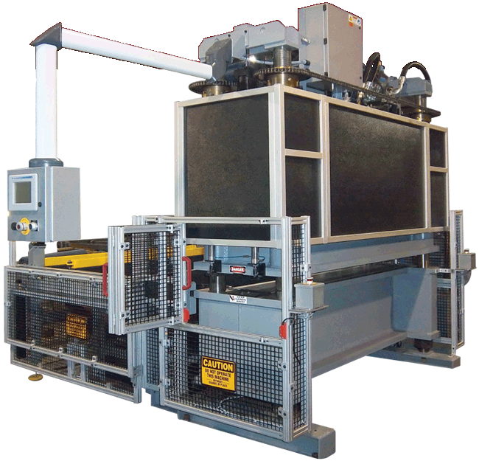
T-Slot Provides Flexible Solutions
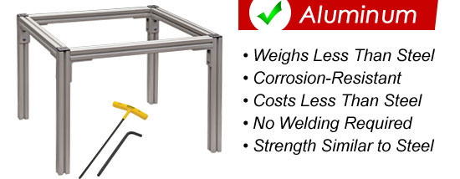
The structure profiles and accessories allow infinite positioning along the T-slot, which equates to reduced set up times and faster changeover rates. With T-slot profiles, you don’t need to compromise between strength, appearance and flexibility.
Benefits of Proactive Guarding
- Our products are aesthetically appealing and won't peel, rust, chip or fade
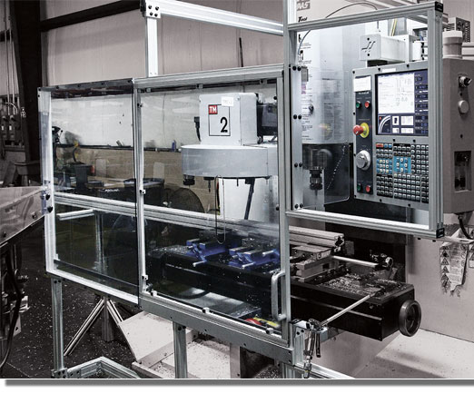
- Easy to clean
- Weighs less than stainless
- Corrosion-Resistant
- Similar strength to steel
-Stainless Steel Hardware
- Accommodate maintenance and repairs
- Easily incorporate other safety components

- Different Guarding systems such as, Thermal plastic coated mesh, clear HDPE panels, or colored Polycarbonate panels
- Fit to your equipment and processes
- Meet or exceed all OSHA regulations
- Easily installed by our service team or you own employees
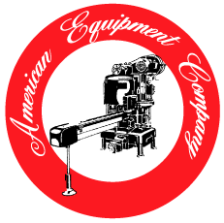
Contact us or email pictures to jessica_adams@seamers.com
Please send high resolution application photos when possible, along with layout and dimensions of area getting guarded.

American Equipment Company / 1080 Hardees Dr. / Aberdeen, MD / 21001
410-272-2626 / www.seamers .com / sales@seamers.com

